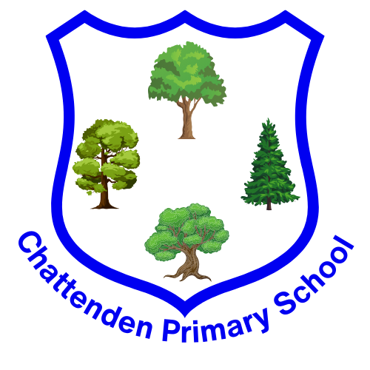

Year 4
Leopards Class
Autumn Terms 1 and 2
Our topic: World War II
Reminders
PE Days
Monday – Swimming
Wednesday – Gymnastics
Reading
Please read with your child daily and record in the reading record.
Homework will be sent home on Fridays and is due the following Friday. Spelling tests will also be on Fridays.
What we will be learning
Throughout the Autumn terms, we will be learning about World War II in History, and this will feature in our writing topics too.

Please follow the link provided to view our current curriculum in full detail. We will be exploring Peace and Conflict, with an emphasis on Freedom. We will also be looking at States of Matter in Science and sketching in Art.


Please remember to login to TTRockstars as
often as possible to prepare for the Year 4
Multiplication Check during the Summer Term.
Events
Trip to Chatham Dockyard – Thursday 25th September. Thank you for your support with transport for this!
TT Rockstars Day – date to be confirmed

